

IMU - CET [WEEKLY TEST]
DATE- 13-09-2025
General instructions:
1. There are 40 questions.
2. All questions has 4 marks for correct and. -1 marks for wrong answer as a penalty
3. The name, date, and exam must be filled in OMR sheet otherwise the result will not be published.
4. OMR fill should be properly

SECTION (A) MATH
DIRECTIONS (Qs. 1-2-3): For the next three (3) items that follow:
Consider the triangle ABC with vertices A (–2, 3), B (2, 1) and C (1, 2).
1. What is the circumcentre of the triangle ABC ?
(a) (–2, –2) (b) (2, 2) (c) (–2, 2) (d) (2, –2)
2. What is the centroid of the triangle ABC ?
(a) $\left(\frac{1}{3},1\right)$ (b) $\left(\frac{1}{3},2\right)$ (c) $\left(1,\frac{2}{3}\right)$ (d) $\left(\frac{1}{2},3\right)$
3. What is the foot of the altitude from the vertex A of the triangle ABC ?
(a) (1, 4) (b) (–1, 3) (c) (–2, 4) (d) (–1, 4)
4. A line passes through (2, 2) and is perpendicular to the line 3x + y = 3. Its y-intercept is
(a) $\frac{3}{4}$ (b) $\frac{4}{3}$ (c) $\frac{1}{3}$ (d) 3
5. The Perpendicular distance between the straight lines 6x + 8y +15 = 0 and 3x + 4y + 9 = 0 is
(a) $\frac{3}{2}$ units (b) $\frac{3}{10}$ unit (c) $\frac{3}{4}$ unit (d) $\frac{2}{7}$ unit
6. The equation of the line joining the origin to the point of intersection of the lines $\frac{x}{a}$ + $\frac{y}{b}$ = 1and $\frac{x}{b}$ + $\frac{y}{a}$ = 1 is
(a) x – y = 0 (b) x + y = 0 (c) x = 0 (d) y = 0
7. If a line is perpendicular to the line 5x – y = 0 and forms a triangle of area 5 square units with co-ordinate axes, then its equation is
(a) x + 5y ± 5$\sqrt{2}$ = 0 (b) x – 5y ± 5$\sqrt{2}$ = 0 (c) 5x + y ± 5$\sqrt{2}$ = 0 (d) 5x – y ± 5$\sqrt{2}$ = 0
8. The line 3x + 4y – 24 = 0 intersects the x-axis at A and y-axis at B. Then the circumcentre of the triangle OAB where O is the origin is
(a) (2, 3) (b) (3, 3) (c) (4, 3) (d) None of the above
DIRECTIONS (Qs. 09-10): For the next two (2) items that follow:
Consider the lines y = 3x, y = 6x and y = 9
9. What is the area of the triangle formed by these lines?
(a)$\frac{27}{4}$ square units (b) $\frac{27}{2}$ square units
(c) $\frac{19}{4}$ square units (d) $\frac{19}{2}$ square units
10. The centroid of the triangle is at which one of the following points?
(a) (3, 6) (b) $\left(\frac{3}{2} ,6\right)$ (c) (3, 3) (d) $\left(\frac{3}{2} ,9\right)$
SPOTTING THE ERROR
SECTION (B) ENGLISH
11. (a) Everybody/ (b) it must be admitted/ (c) has their ups and downs./ (d) No error
12. (a) Every woman in the world/ (b) fervently hopes that their child/ (c) will be a normal and healthy baby/ (d) No error
13. (a) Neither of them/ (b) sent their papers/ (c) in time for the last seminar/ (d) No error
14. (a) This is a strange world/ (b) where each one pursues their own golden bubble/ (c) and laughs at others for doing the same./ (d) No error
15. (a) If it were possible to get near when/ (b) one of the volcanic eruptions take
16. (a) A rise in rents and wages/ (b) have been found/ (c) to go together./ (d) No error
17. (a) He is one of those few post-colonial writer who believes/ (b) that this talk about colonialism has gone too far/ (c) and has turned into a cliche./ (d) No error
18. (a) One of the peculiarities/ (b) which distinguishes the present age/ (c) is the multiplication of books/ (d) No error
19. (a) Neither of them/ (b) are going to attend/ (c) the party on 10th October/ (d) No error
20. (a) Ten miles are/ (b) a long distance / (c) to cover on foot./ (d) No error
SECTION (C) CHEMISTRY
21. Formaldehyde on oxidation gives:
(a) Methanol (b) Methanoic acid (c) Acetaldehyde (d) Acetic acid
22. Ketones can be reduced to secondary alcohols using:
(a) LiAlH₄ (b) H₂/Ni (c) NaBH₄ (d) All of these
23. In IUPAC nomenclature, the suffix used for aldehydes is:
(a) –al (b) –one (c) –oic acid (d) –ol
24. Aldehydes are more reactive than ketones due to:
(a) +I effect of alkyl group (b) Steric hindrance in ketones
(c) Less electron donation by H (d) All of these
25. The carbonyl carbon in aldehydes and ketones is electrophilic because:
(a) Oxygen is more electronegative than carbon (b) Carbon has a partial negative charge
(c) Oxygen donates electrons (d) None of these
26. On oxidation, benzaldehyde gives:
(a) Benzoic acid (b) Benzene (c) Benzyl alcohol (d) Phenol
27. The correct order of reactivity of aldehydes towards nucleophilic addition is:
(a) Formaldehyde > Acetaldehyde > Benzaldehyde (b) Benzaldehyde > Acetaldehyde > Formaldehyde
(c) Acetaldehyde > Formaldehyde > Benzaldehyde (d) Formaldehyde > Benzaldehyde > Acetaldehyde
28. Which of the following is most reactive towards nucleophilic addition?
(a) Formaldehyde (b) Acetaldehyde (c) Acetone (d) Benzaldehyde
29. The IUPAC name of acetone is:
(a) Propanal (b) Propanone (c) Butanone (d) Ethanone
30. Aldol condensation is shown by:
(a) Aldehydes having no α-hydrogen (b) Ketones having α-hydrogen
(c) Both aldehydes and ketones with α-hydrogen (d) Aromatic aldehydes
SECTION (D) PHYSICS
31. An electric dipole is placed at an angle of 30° with an electric field of intensity 2×10⁵ N C ⁻¹ . It experiences a torque equal to 4 N m. Calculate the charge on the dipole if the dipole length
is 2 cm.
(a) 8 Mc (b) 4 mC (c) 6 mC (d) 2 mC
32. An electric dipole is placed in an uniform electric field with the dipole axis making an angle θ with the direction of the electric field. The orientation of the dipole for stable equilibrium is
(a) $\frac{π}{6}$ (b) $\frac{π}{3}$ (c) 0 (d) $\frac{π}{2}$
33. Consider a uniform electric field E = 3×10³ $\hat{j}$ N/C. What is the flux of this field through a square of 10 cm on a side whose plane is parallel to the yz plane?
(a) 10 N C⁻¹ m² (b) 20 N C⁻¹ m² (c) 30 N C⁻¹ m² (d) 40 N C⁻¹ m²
34. The electric field in a region is given by $\vec{E}$ = a $\hat{i}$ + b $\hat{j}$ , where a and b are constants . the net electric flux passing through a square area of side I parallel to y –z plane is
(a) a² I² (b) a I² (c) b² I² (d) bI²
35. A charge Q μC is placed at the centre of a cube, the flux coming out from any face will be
(a) $\frac{Q}{6 {ε }_{0}}$ × 10⁻⁶ (b) $\frac{Q}{ 6{ε }_{0}}$ × 10⁻³ (c) $\frac{Q}{ 24 {ε }_{0}}$ (d) $\frac{Q}{ 8 {ε }_{0}}$
36. Eight dipoles of magnitude eα are placed inside a cube. The total electric flux coming out of the cube will be
(a) $\frac{8e}{{ϵ }_{0}}$ (b) $\frac{16 e}{{ϵ }_{0}}$ (c) $\frac{e}{{ϵ }_{0}}$ (d) zero
37. The adjoining figure shows a spherical Gaussian surface and a
charge distribution. When calculating the flux of electric field through the
Gaussian surface, the electric field will be due to
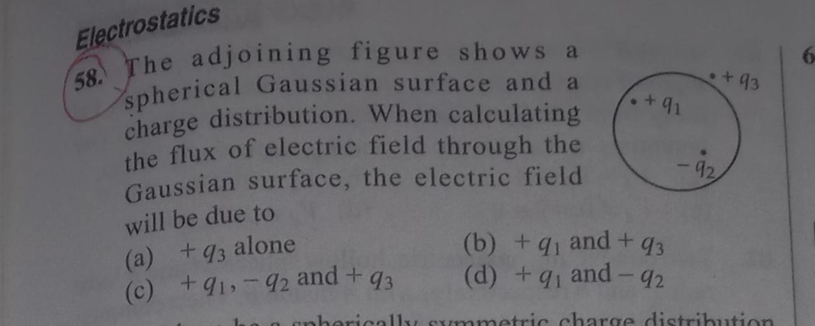
(a) + q₃ alone (b) + q ₁ and + q₃ (c) + q₁ , - q₂ and + q₃ (d) + q₁ and – q²
38. The total electric flux emanating from a closed surface enclosing an α-particle in terms of e (electric charge) is
(a) $\frac{2e}{ε_{0}}$ (b) $\frac{e}{ε_{0}}$ (c) $\frac{{ε_{0}}^{e}}{ε_{0}}$ (d) $\frac{4e}{ε_{0}}$
39. Gauss's law of electrostatics would be invalid if
(a) there were magnetic monopoles
(b) The speed of light was not a universal constant
(c) The inverse square law was not exactly true
(d) The electrical charge was not quantized
40. A charge 10 μC is placed at the centre of a hemisphere of radius R = 10 cm as shown. The electric flux through the hemisphere (in MKS units) is
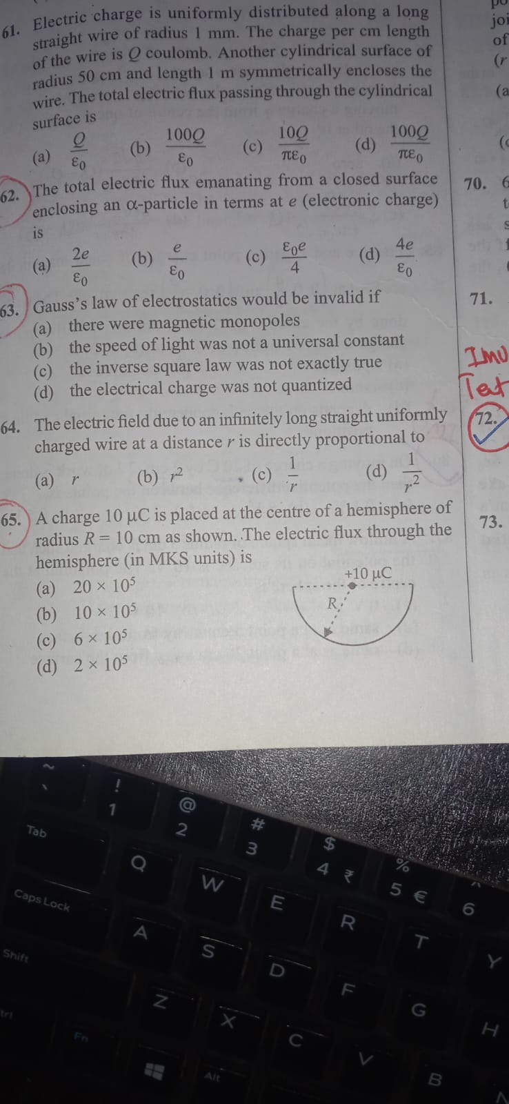

(a) 20 × 10⁵ (b) 10 × 10⁵ (c) 6 × 10⁵ (d) 2 ×10⁵
Section (D) Reasoning
41.When a watch shows 3:45, the minute-hand points towards East. When the watch shows 6:00, in what direction will the hour-hand point?
(a) East (b) West (c) South (d) North
42. A compass was damaged and its needle turned in such a manner that the pointer, which normally shows West, is now showing South. If a person, who is following the damaged compass, went towards geographical North, in which direction did he actually want to go?
(a) North (b) South (c) West (d) East
43. A compass was damaged and its needle turned in such a manner that the pointer, which was showing East, now showed North. One person went towards West as per the above mentioned compass. In which direction did he actually go?
(a) South-West (b) South (c) North-East (d) North
44. Rahul, who is facing West, turns 120° in the clockwise direction and then 155° in the anti-clockwise direction. Which direction is he facing now?
(a) North (b) North-East (c) South-West (d) West
45. A man facing South-West turns 180° in the clockwise direction and then turns 45° in the anti-clockwise direction. Which direction is he facing now?
(a) North (b) North-East (c) South (d) South-East

46. One morning, A and B started walking in opposite directions. When they met, A observed that B’s shadow was falling to the right of B. In which direction was A walking?
(a) North (b) East (c) South (d) West
47. One evening, Anil and Sunil were walking in opposite directions towards each other. When they met, Anil observed that his shadow is falling to the right of Sunil. In which direction is Sunil moving?
(a) East (b) North (c) West (d) South
48. There are five towns A, B, C, D and E. A is to the north-east of C, B is to the west of A and north-west of C and D is to the south-west of C and E is to the north of C. Then in which direction is E located with respect to D?
(a) North-West (b) North (c) South-West (d) North-East
49. Suraj starts from his house, and travels a distance of 6 km towards south. Then he turns to his right and travels a distance of 8 km. Finally he travels 10 km towards north to reach the cricket ground. What is the distance between Suraj’s house and the cricket ground?
(a) 10 km (b) 4√3 km (c) 4√5 km (d) None of these
50. Harshan travels 9 km towards west and then 6 km towards his left. Then he turns towards east and travels 2 km. Finally he travels 5 km towards north. How far is he from the starting point?
(a) 5√3 km (b) 5 km (c) 5√2 km (d) None of these

Answer key
MATH
1. A 2. B 3. D 4. B 5. B 6. A 7. A
8. C 9. A 10. B
ENGLISH
11. C 12. B 13. B 14. B 15. B 16. B 17. A
18. B 19. B 20. A
CHEMISTRY
21. B 22. D 23. A 24. D 25. A 26. A 27. A
28. A 29. B 30. B
PHYSICS
31. d 32. c 33. c 34. b 35. a 36. d 37. c
38. a 39. c 40. c
REASONING
41. D 42. D 43. D 44. C 45. A 46. A 47. B
48. D 49. C 50. C

