

IMU - CET [WEEKLY TEST]
DATE- 20-09-2025
General instructions:
1. There are 50 questions.
2. All questions has 4 marks for correct and. -1 marks for wrong answer as a penalty
3. The name, date, and exam must be filled in OMR sheet otherwise the result will not be published.
4. OMR fill should be properly

SECTION [A] ENGLISH
SPOTTING THE ERROR
1. (a) If he came to me / (b) I would have given / (c) him my car. / (d) No error
2. (a) Had he invited me / (b) I would have attended / (c) the function. / (d) No error
3. (a) If he had called me up / (b) I would inform / (c) him ./ (d) No error
4. (a) If he will work hard / (b)/ he will surely / (c) get the job of his choice. / (d) No error
5. (a) Unless I do not / (b) see his ticket, / (c) I will not let him sit here. / (d) No error
6. (a) Before the police will come / (b) You should better / (c) get the anticipatory bail. / (d) No error
7. (a) We will come to know the truth / (b) after / (c) the investigation finished. / (d) No error
8. (a) Until the train will not get the signal , (b) it will not / (c) leave the platform. / (d) No error
9. (a) If I had money / (b) I will have lent / (c) it to her. / (d) No error
10. (a) If I was you / (b) I would not tolerate him / (c) for a moment. / (d) No error
SECTION [B] MATHEMATICS
11. What is one of the values of $\sqrt{i}$+ $\sqrt{- i}$
(a) $\sqrt{2}$ (c) 0 (c) $±$ $\frac{1+i}{\sqrt{2}}$ (d) $±$ $\frac{1-i}{\sqrt{2}}$
12. What is the value of ${\left(-\sqrt{-1}\right)}^{4n+3}$ + ${\left(i^{41}+i^{-257}\right)}^{9}$ , where n $ϵ$N ?
(a) 0 (b) 1 (c) i (d) –i
13. What is the modulus of $\left|\frac{1+2i}{1{-\left(1-i\right)}^{2}}\right|$?
(a) 1 (b) $\sqrt{5}$ (c) $\sqrt{3}$ (d) 5
14. What is the least positive integer n for which ${\left(\frac{1+i}{1-i}\right)}^{n}$= 1?
(a) 16 (b) 12 (c) 8 (d) 4
15. What is the value of 1+ i² + i⁴ + i⁶ +....+i¹⁰⁰ , where i = $\sqrt{-1}$ ?
(a) 0 (b) 1 (c) -1 (d) None of these
16. If z = $\frac{1+2i }{2-i }$ - $\frac{2-i}{1+2i}$ , then what is the value of z² + z$\overline{z}$ $\left(i=\sqrt{-1}\right)$?
(a) 0 (b) -1 (c) 1 (d) 8
17. The value of the sum $\sum_{n=1}^{13}{\left(i^{n}+ i^{n+1}\right)}$ where i = $\sqrt{-1}$ is:
(a) i (b) –i (c) 0 (d) i – 1
18. What is $\frac{{\left(1+i\right)}^{4n+5}}{{\left(1-i\right)}^{4n+3}}$ equal to, where n is a natural number?
(a) 2 (b) 2i (c) -2 (d) i
19. What is the value of the sum $\sum_{n=2}^{11}{\left(i^{n}+ i^{n+1}\right)}$ , where i = $\sqrt{-1}$ ?
(a) i (b) 2i (c) -2i (d)1+i
20. The smallest positive integer n for which ${\left(\frac{1-i}{1+i}\right)}^{n^{2}}$where i = $\sqrt{-1}$, is
(a) 2 (b) 4 (c) 6 (d) 8
Section [c] chemistry
21. The diagonal relationship exists between:
(a) C and N (b) B and Si (c) N a and K (d) Li and Be
22. Which of the following elements has the lowest first ionization enthalpy?
(a) Li (b) He (c) Cl (d) Cs
23. The property that is not a periodic trend is:
(a) Nuclear stability (b) Electronegativity (c) lonization enthalpy (d) Atomic radius
24. which of the following elements has the highest Electron affinity?
(a) f (b) S (c) Cl (d) O
25. The size of cation is always:
(a) The same as its parent atom. (b) Larger than its parent atom.
(c) Smaller than its parent atom. (d) Smaller than its corresponding anion
26. The general electron configuration for d- block elements is :
(a) [noble gas] ns¹⁻² (n – 1) d¹⁻ ¹⁰ (b) [noble gas]ns¹⁻²
(c) [noble gas]ns¹⁻² np¹⁻⁶ (d) [noble gas] ns² (n – 2) f¹⁻ ¹⁴
27. Which of the following has the smallest size?
(a) Na⁺ (b) F ⁻ (c) Al³⁺ (d) Mg²⁺
28. The element with the electron configuration [Ar] 3d¹⁰ 4s² 4p⁵ is a:
(a) Halogen (b) Transition element (c) Alkaline earth metal (d) Noble gas
29. The correct order of increasing atomic radii for the elements O,F,N, and C is:
(a) C<N<O<F (b) O<F<N<C (c) F<O<N<C (d) F<N<O<C
30. Which of the following elements has the highest first ionization enthalpy
(a) Na (b) K (c) Mg (d) Ne
SECTION [D] REASONING
31. A and B working together can do 45% of the work in 9 days. A alone can do the work in 30 days. How many days will B alone take to do the same work?
(a) 60 (b) 70 (c) 48 (d) 50
32. A, B and C can do a work in 4, 20 and 60 days respectively. Working together, they can complete the one third work in how many days?
(a) $\frac{20}{19}$ (b) $\frac{20}{9}$ (c) $\frac{12}{19}$ (d) $\frac{17}{19}$
33. A can finish a piece of work in 48 days and B can finish it in 60 days. They work together for 12 days and then A goes away. In how much time (in days and hours) will B finish 25% of the remaining work?
(a) 6 days 4 hours (b) 8 days 8 hours (c) 6 days 6 hours (d) 8 days 6 hours
34. A and B working alone can complete a work in 8 days and 12 days, respectively. They started working together, but A left 2 days before completion of the work. In how many days was the work completed?
(a) 6 (b) 5 (c) 8 (d) 10
35. A and B can do a work in 10 and 12 days respectively. They begin the work together but A left the work 1 day before the completion of work. In how many days will the total work be completed?
(a) 5 days (b) 8 days (c) 2 days (d) 6 days
36. A work is done by P & Q, Q & R, and R & P in 12, 15, and 20 days, respectively. How many days will P alone take to complete the work?
(a)35 days (b) 25 days (c) 40 days (d) 30 days
37. A, B and C can do a work in 12, 15 and 20 days respectively. In how many days will they complete the same work together?
(a) 10 days (b) 5 days (c) 6 days (d) 7 days
38. C and D together can make a chair in 4 days and C alone can make this chair in 12 days. In how many days D alone can make this chair?
(a) 10 day (b) 6 days (c) 4 days (d) 8 days
39. A can do a piece of work in 12 days whereas B can do the same work in 18 days. In how many days (A & B) together can do the same work if they are working together?
(a)7$\frac{2}{5}$ (b) 7 $\frac{1}{5}$ (c) 8$\frac{2}{5}$ (d) 8 $\frac{1}{5}$
40. To do a certain work, efficiencies of A and B are in the ratio 7 : 5. Working together, they can complete the work in 17 $\frac{1}{2}$ days In how many days, will B alone complete 50% of the same work?
(a) 50 (b) 30 (c) 42 (d) 21
SECTION [E] PHYSICS
41. A parallel plate capacitor of capacitance 5 $μ$F and plate separation 6 cm is connected to a 1 V battery and charged. A dielectric of dielectric constant 4 and thickness 4 cm is introduced between the plates of the capacitor. The additional charge that flows into the capacitor from the battery is
(a) 2 $μ$C (b) 3 $μ$C (c) 5 $μ$C (d) 10 $μ$C
42. Two metal plate form a parallel plate capacitor. The distance between the plates is d. A metal sheet of thickness d/2 and of the same area is introduced between the plates. What is the ratio of the capacitances in the two cases?
(a) 4 : 1 (b) 2 : 1 (c) 3 : 1 (d) 5 : 1
43. A parallel plate capacitor is connected to a 5 V battery and charged. The battery is then disconnected and a glass slab is introduced between the plates. Then the quantities that decrease are
(a) charge and potential difference
(b) charge and capacitance
(c) energy stored and potential difference
(d) energy stored and capacitance
44. In a parallel plate capacitor, if the intervening medium of permittivity ε between the plates is replaced by another medium of permittivity $\frac{ε}{2}$, then its capacitance is
(a) halved (b) doubled (c) unchanged (d) quadrupled
45. Six equal capacitors each of capacitance C are connected as shown in the figure. Then the equivalent capacitance between A and B is
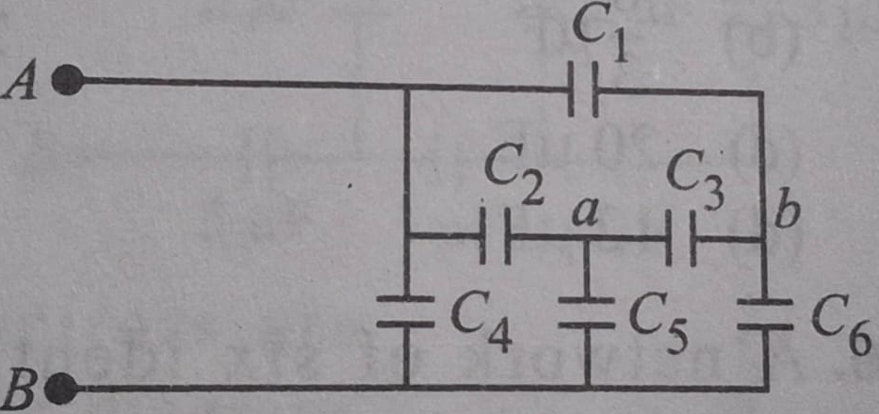
(a) 6C (b) C (c) 2C (d) C/2
46. Figure shows three capacitors connected to a 6 V power supply. What is the charge on the 2 μF capacitor?
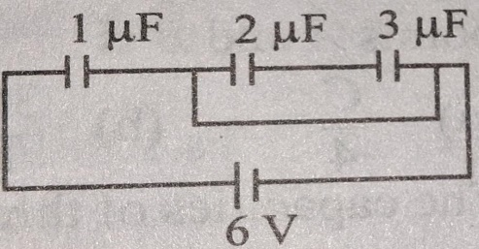

(a) 1 μC (b) 2 μC (c) 3 μC (d) 4 μC
47. Two capacitors A (2 μF) and B (5 μF) are connected to two batteries as shown in the figure. Then the potential difference in volts between the plates of A is
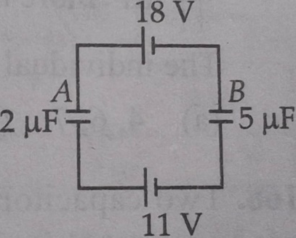
(a) 2 (b) 5 (c) 11 (d) 18
48. In this diagram, the P.D. between A and B is 60 V. The P.D. across 6 μF capacitor is

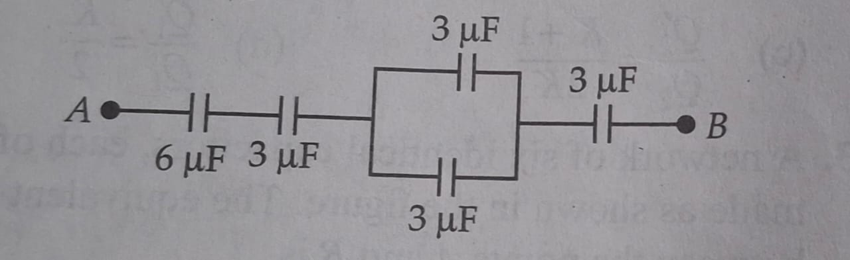
(a) 10 V (b) 5 V (c) 20 V (d) 4 V
49. A parallel plate air capacitor has a capacitance C. When it is half filled with a dielectric of dielectric constant 5, the percentage increase in the capacitance will be
(a) 400% (b) 66.6% (c) 33.3% (d) 200%
50. If the equivalent capacitance between P and Q of the combination of the capacitors shown in figure below is 30 μF, the capacitor C is
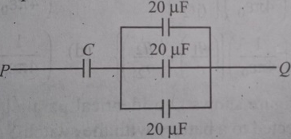
(a) 60 μF (b) 30 μF (c) 10 μF (d) 5 μF
Answer key
English
- A 2. D 3. B 4. A 5. A 6. A 7. C 8. A 9. B 10. A
MATHEMATICS
11. A 12. C 13. A 14. D 15. B 16. A 17. D 18. A 19. C 20. A
CHEMISTRY
21. B 22. D 23. A 24. A 25. C 26. A 27. C 28. A 29. C 30. D
REASONING
31. A 32. A 33. D 34. A 35. D 36. D 37. B 38. B 39. B 40. D
PHYSICS
41. C 42. B 43. C 44. A 45. C 46. B 47. B 48. A 49. B 50. A

